##### **Test Data Set Availability with Test Results**

This is the home page of our application. We will input the desired skills for the job in the input field and upload a zip folder, which should contain all the resumes to be scored and ranked.

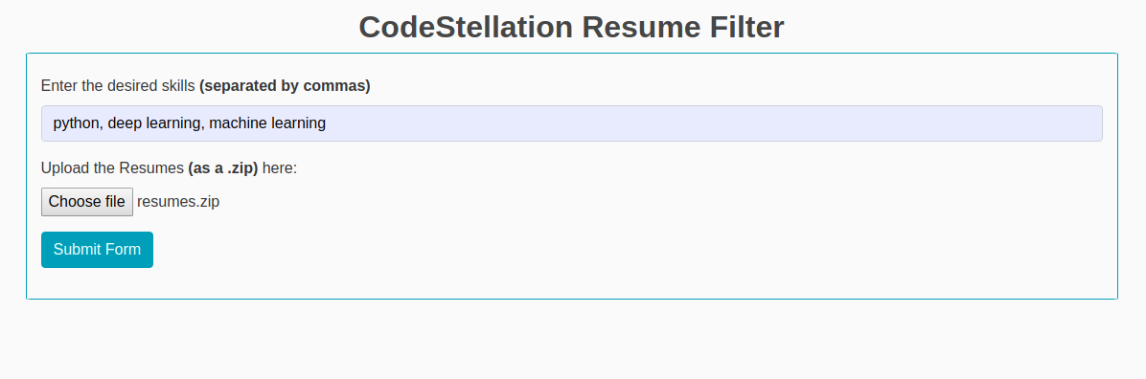

Below is the output. Please note, that the ranking feature will be updated in the next assessment (working prototype).

Our **input test data** is a .zip folder of resumes.

Our **output test results** is the score of the resumes, that have been uploaded.

